5.4 TEST MS
1. (i) An atom, ion or molecule which can donate a lone electron pair 1
(ii) A central metal ion/species surrounded by co-ordinately bonded ligands 1
or ion in which co-ordination number exceeds oxidation state
(iii) The number of co-ordinate bonds formed to a central metal ion 1
or number of electron pairs donated or donor atoms
[3]

2. (a) Electron transitions/electrons excitedin d shell (1) or d-d transition
Do NOT allow charge transfer
(Energy in) visible range (1)
(NOT emits in visible region)
2
(b) Change 1: (Different) oxidation states (1)
Change 2 : (Different) ligands (1)
Change 3: (Different) co-ordination number (1)
Do not allow shape as an answer
3
(c) Add an appropriate (or a given correct) ligand to intensify colour (1)
e.g. thiocyanate (CNS)— or bipyridyl
Make up solutions of known concentration (1)
Measure absorption or transmission (1)
Plot graph of results or calibration curve (1)
Measure absorption of unknown and (1)
compare
N.B.: Allow concentration statement if included in graph statement
Allow adsorption but circle the d
Also
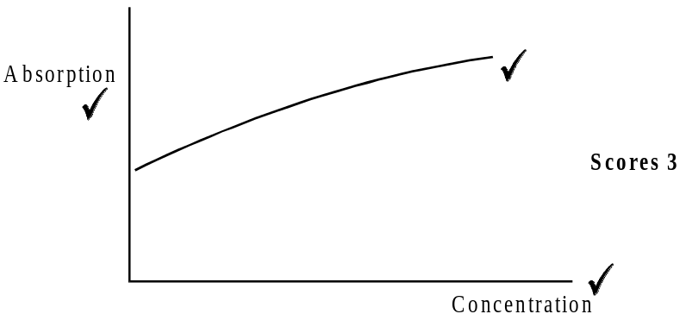
5
[10]
3. (a) (i) Two (1) lone pair donor / electron pair donor (1) atoms
Allow:– forms two co-ordinate bonds (1)
NOT atom with two lone pairs
(ii) 5
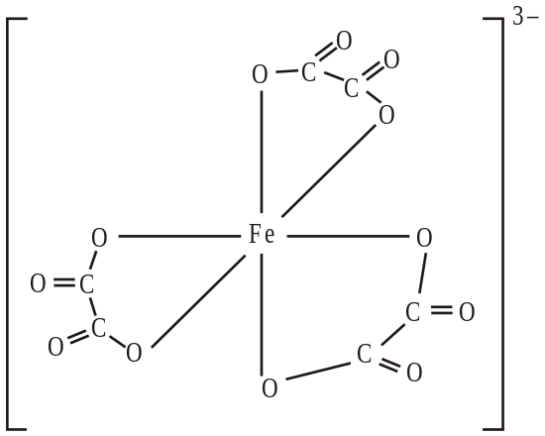
Correct ligand structure (1) 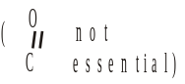
penalise any error
Six correct O–Fe bonds (1)
Correct charge (1)
N.B. Penalise the second mark if arrow from Fe shown
N.B. Ignore charges on atoms
(b) (i) [AgCl2]– or AgCl2– (1)

(ii) Chloride or Cl– big or large or repel (1) 2
NOT Cl2 or Cl+ or Cl
Allow ‘chlorine ion’
[7]

4. (a) (i) H2O2 (1) plus NaOH (1)
only allow if H2O2 given
Alkaline H2O2 scores (1)
Na2O2 scores (2)
(ii) Zn (1) plus HCl/H2SO4 (1)
only allow if Zn given
Ignore conc
Not HNO3
(iii) A named aldehyde or a correct formula clearly with an aldehyde gropup (1) 5
or Cu → Mg
(b) (i) Half-equation for the oxidation of H2O2
H2O2 → O2 + 2H+ + 2e– (or multiple) (1)
Half-equation for the reduction of manganate(VII) ions
MnO4– + 8H+ + 5e– → Mn2+ + 4H2O (or multiple) (1)
Overall equation
2MnO4– + 5H2O2 + 6H+ → 2Mn2+ + 5O2 + 8H2O (1)
only allow this or multiple
(ii) Moles MnO4– = mv/1000 = (2.82 to 2.83) × 10–4 (1)
Moles H2O2 = 2.826 × 10–4 × 5/2 (1) = (7.06 to 7.08) × 10–4
mark conseq to equation in b(i)
[H2O2] = 7.065 × 10–4 × 1000/20 (1) = (3.53 to 3.54) × 10–2
Mass = moles × Mr = 3.53 × 10–2 × 34
= 1.2(0) (1) 7
Ignore units
Max 3 if ratio 2/5 used. (Final answers 0.19)
N.B. Using 3:5 ratio
Moles MnO4– = (2.82 to 2.83) × 10–4 (1)
Moles [H2O2] = 2.826 × 10–4 × 5/3 (1) = (470 to 472) × 10–4
[H2O2] = 4.71 × 10–4 × 1000/20 (1) = (2.35 to 2.36) × 10–2
Mass = 0.8(0) (1) (i.e. 2 sig fig required)
[12]

5. (i) (Both) ions are negative or ions repel or High Ea (1)
(ii) Meaning of the term autocatalytic: A product of the reaction acts
as a catalyst (1)
NOT a self catalysing reaction (0)
Catalyst: Mn2+ or Mn3+ (1)
(iii) Mn2+ converted into Mnn+ or Mn2+ oxidised (1)
Mnn+/oxidised species then oxidises/reacts with C2O42– (1) 5
[5]

6. (a) V2O5 or NH4VO3 or name (1)
xs (1) Zn (1) HCl or dil H2SO4 (1)
abscence of air (1) colours seen (1)
V(IV), V(III), V(II) seen (1) max 6
(b) speeds rate (1) unchanged at end (1)
different route/intermediate mechm (1)
lower AE (1) different phase (1)
contact process/SO3 or H2SO4 manufacture (1)
V2O5 + SO2 → V2O4 (2VO2) + SO3 (1)
V2O4 (2VO2) + ½O2 → SO3 (1)
SO2 + ½ O2 → SO3 (1)
change of oxidation state of
vanadium stated (1) max 9
[15]

